CAMEROON EQUITY PROFILE
The Cameroon (DHS 2018) equity profile consists of 5 pages presenting the patterns and magnitudes of inequalities in coverage of key reproductive, maternal, newborn, and child health (RMNCH) interventions. The first page displays a map showing the regional distribution of the composite coverage index (CCI), as well as graphs with intervention coverage and prevalence of “zero care” (which refers to the proportion of women and children not being reached by any MNCH and immunization interventions). The second, third, and fourth pages present tables with detailed data on coverage levels by key equity stratifiers (wealth, women’s education, child’s sex, urban/rural, subnational region, women’s empowerment, women’s age, ethnicity, and religion) for 15 individual interventions plus the CCI. Prevalence values are also presented for zero maternal and newborn health and for zero dose children for each of these stratifiers. The last page provides definitions for the interventions and inequality measures shown on the profile.
Key messages
- Wealth plays a major role in inequality. Women and children from the richest families receive more health services than those from poorer households. The poorest are also much more likely to receive no care at all.
- Regional differences are very large. Some regions, such as the Sud Ouest, have significantly higher CCI coverage than others, especially compared to the northern regions (Extrême-Nord, Nord, and Adamaoua). The difference in overall health coverage between the best-performing and worst-performing regions is over 35 percentage points.
- People in rural areas have less access to interventions. Urban areas show higher coverage for most interventions, especially for antenatal care, skilled delivery, and postnatal care. Early initiation and exclusive breastfeeding are similar in urban and rural areas, whereas continued breastfeeding is much more common among rural women.
- Ethnic and religious differences remain. The Fulfulde ethnic group faces major disadvantages in both maternal and newborn care and in vaccination. Differences across religious groups are also marked, with those identifying as Animist and with no religious affiliation being the most disadvantaged.
- Too many children still receive no vaccines. About 17% of children did not receive any dose of the DPT vaccine. This proportion is much higher among children from poor families, women with little or no education, and those living in the north, showing that immunization services are not yet reaching everyone.
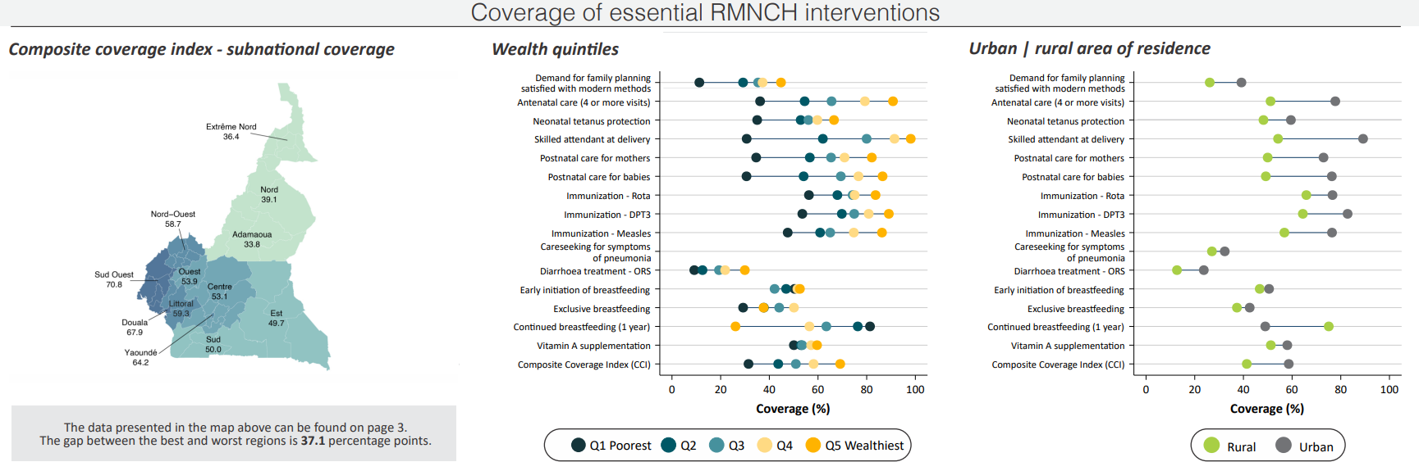
Intervention Coverage by Region, Wealth, and Area of Residence
These graphs provide snapshots of reproductive, maternal, newborn, and child health (RMNCH) intervention coverage. The map presents the subnational distribution of the Composite Coverage Index (CCI), a summary measure of eight key health interventions, across Burkina Faso's regions; darker colors mean higher (better) coverage. The equiplot in the middle shows coverage with 15 health interventions plus the CCI for the five wealth quintiles, from the poorest 20% (Q1) to the wealthiest 20% (Q5). The equiplot on the right shows coverage with the same indicators for rural and urban areas. In these plots, the ideal scenario would be to see all dots clustered together on the far right, indicating high and equitable coverage. The coverage and prevalence of all indicators by country regions are presented on page 3 of the profile. The coverage of all indicators by wealth and area is presented on page 2 of the profile.
- Map of subnational CCI coverage: The northern regions of Cameroon lag far behind. CCI coverage ranges from up to 70% in the western regions to below 40% in the Nord and Extrême-Nord regions. These large inequalities show that some areas still struggle to reach women and children with essential health services.
- Equiplot with intervention coverage by wealth: Wealth inequalities are huge. The gap between the richest and poorest families exceeds 50 percentage points for antenatal care (four or more visits), skilled delivery, and postnatal care. Vaccine coverage is less unequal, but differences of up to 39 percentage points still exist. Continued breastfeeding is the only indicator with the opposite pattern — poorer women are more likely to breastfeed for a year or more.
- Equiplot with intervention coverage by area of residence: Women and children in cities have better access to almost all services. Patterns are similar to those by wealth but not as large. Urban coverage is higher for deliveries in health facilities, antenatal visits, postnatal care and vaccination. Rural areas, however, show better results for continued breastfeeding.

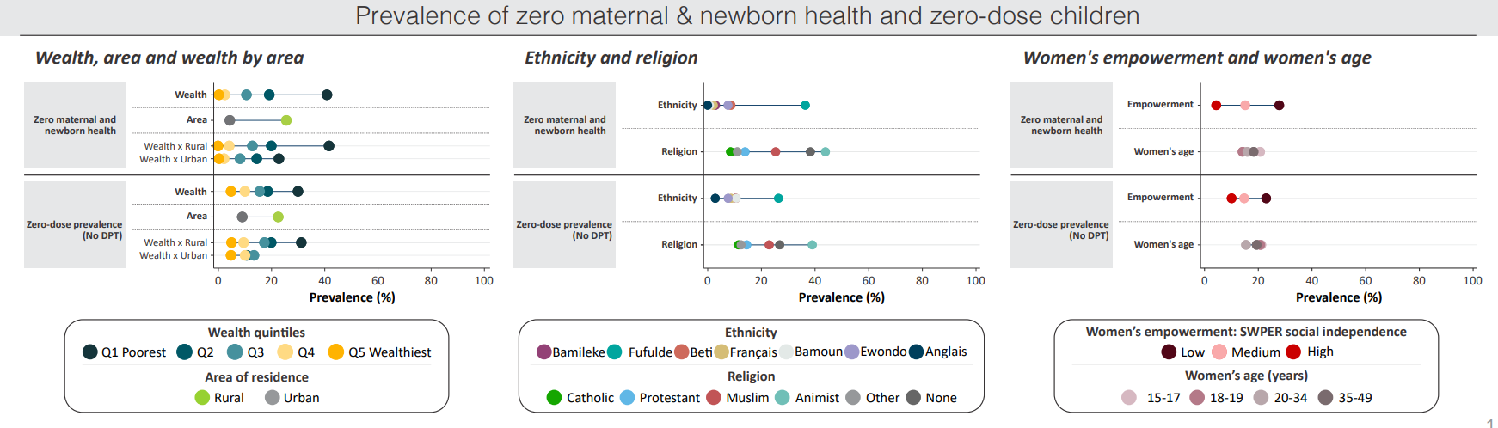
Prevalence of “Zero Care”
The bottom graphs shift the focus to "negative" indicators, measuring the proportion of the population that receives no care. These graphs show the prevalence of zero maternal and newborn health, or zero MNH (none of three key maternal services) and zero dose prevalence (children who received no DPT vaccine). For these indicators, the goal is for all dots to be as close to zero as possible.
- By wealth and area: The poorest families, especially those living in rural areas, are the most affected. Around 31% of the poorest children are zero-dose, compared with about 5% among the wealthiest. Zero MNH also follows the same pattern, with much higher prevalence among poor rural families.
- By ethnicity and religion: The Fulfulde group shows the highest levels of zero care, reaching up to two or three times the national average. Among religions, families identifying as Animist and people with no religious affiliation show higher levels of both zero-dose and zero MNH.
- By women’s empowerment and age: Women with low empowerment are less likely to receive care. Differences by age are small, with slightly better results for older women. This shows that social and personal factors strongly affect access to health services.

INTERPRETATION OF THE TABLES
Table 1 – National Indicators by Equity Stratifiers (Page 2)
This table provides detailed national data for RMNCH indicators, broken down by wealth, women’s education, child's sex, and area of residence. It also includes summary measures of wealth inequality: the richest/poorest ratio and difference of coverage or prevalence, the concentration index, and the slope index of inequality (definitions on page 5).
- Coverage of interventions: Coverage levels are moderate for skilled delivery (70%) and antenatal care (63%), largely influenced by low coverage among the poorest, rural populations and women with no education. Vaccines such as DPT3 (72%) and rotavirus (70%) have good coverage overall, though the poorest are still behind. Careseeking for pneumonia (30%) remains very low across all groups.
- Breastfeeding: Poorer mothers and those living in rural areas are typically more likely to breastfeed. Continued breastfeeding show higher coverage among poor (76%) and rural (75%) families. The prevalence of exclusive and early initiation of breastfeeding varies across the groups, with no clear or consistent pattern.
- Zero care: Around 17% of children received no vaccines, with poorer and rural children presenting the highest prevalences. Inequalities are much more significant for women and babies that had no contact with maternal and newborn health services. The prevalence of zero MNH is as high as 41% in the poorest families and 40% among women with no education.
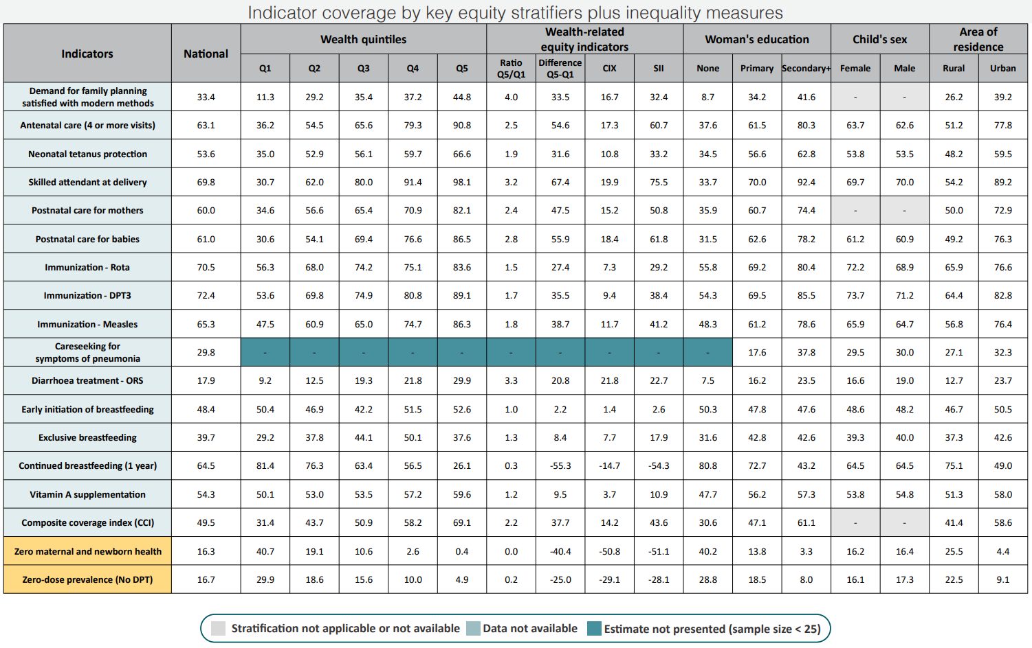

Table 2 – Coverage by Region (Page 3)
This table presents a detailed breakdown of coverage for every indicator across all 12 regions of Cameroon.
- Regional inequalities: The northern and eastern regions (Extrême-Nord, Nord, Adamaoua, Est) have the lowest coverage levels. For example, in Extrême-Nord, only about 41% of births are assisted by a skilled attendant and just 46% of women receive antenatal care. In contrast, Yaoundé and Douala perform much better, with coverage above 80% for most interventions.
Immunization coverage is lowest in the same low-performing regions, where many children are still zero-dose. These differences reflect the uneven distribution of services and resources across the country.
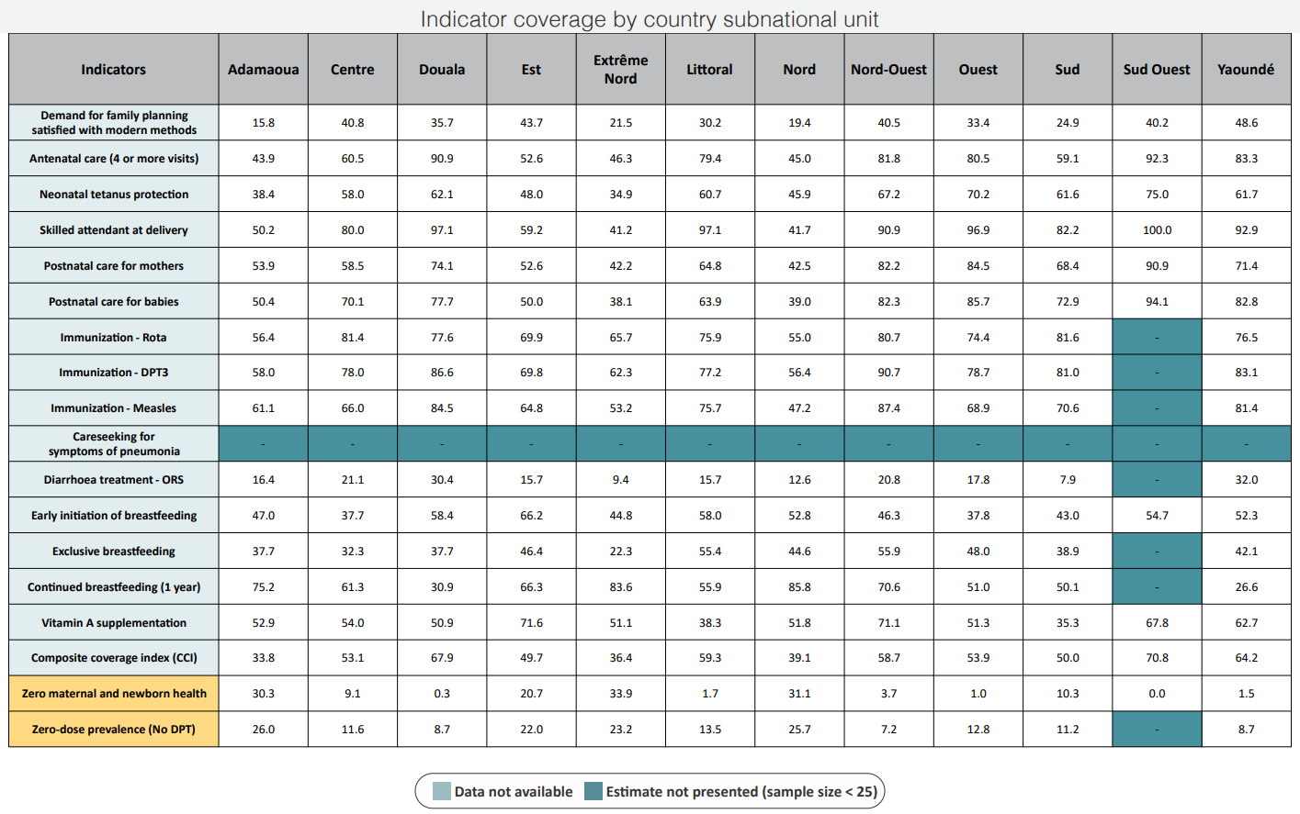

Table 3 – Analysis of “Zero Care” Indicators (Page 4)
These tables offer a more detailed look at the populations most affected by a complete lack of care, stratifying the "Zero maternal and newborn health" and "Zero DPT prevalence" indicators by area, ethnicity, and religion.
- Interpretation: The Fulfulde ethnic group has one of the highest rates of women with zero maternal and newborn care (about 37%), more than twice the national average. The Haoussa group also shows very high rates, although they represent only 1.6% of the women 15-49 population. Among religious groups, Muslims have higher levels of zero care than Christians. But those identifying as Animist and with no religious affiliation show the highest prevalence of zero-care, especially for zero MNH.
- Regional and social patterns: Many of these groups live in the northern regions, where services are harder to reach. This overlap of poverty, geography, and social factors explains much of the inequality observed in Cameroon.
